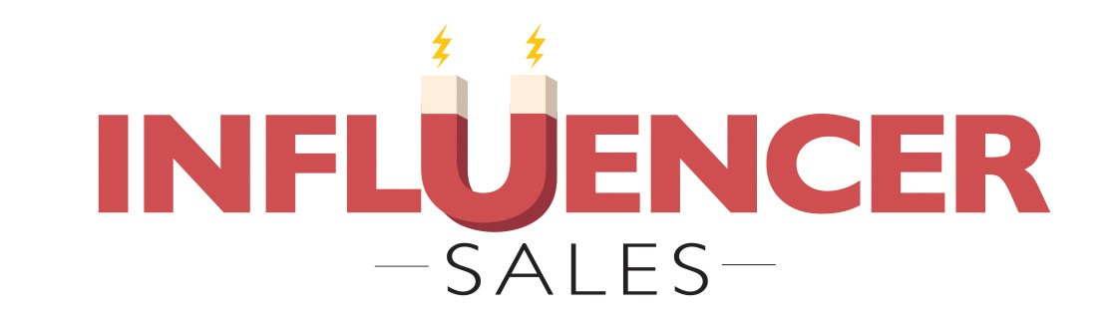
Building Your Account
Touchpoint Blueprint
--
Introduction
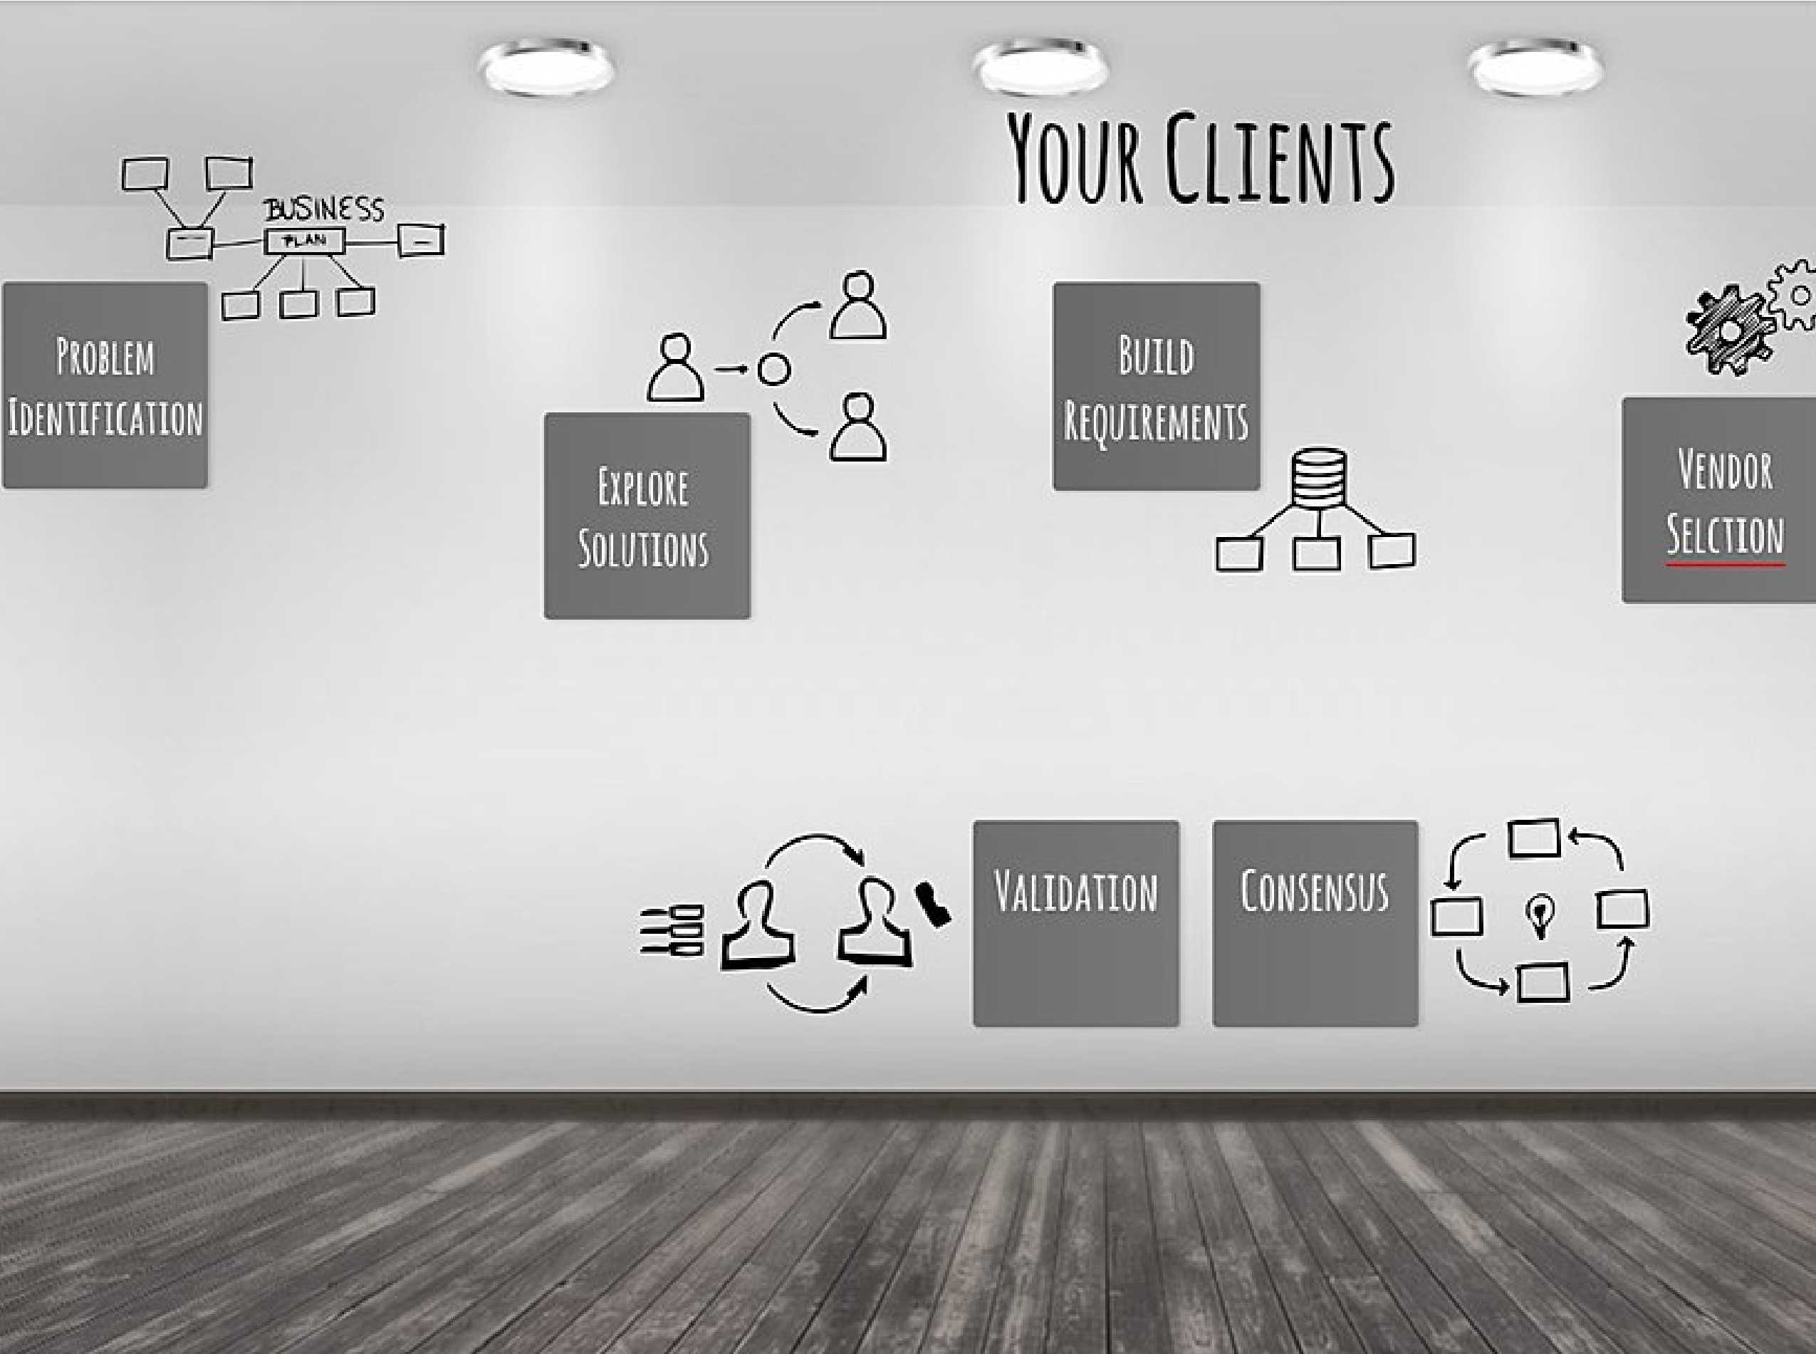
This workbook allows you to think through key elements for building your account touchpoint blueprint. The more thought you put into this up front, the more useful this will be in the future, so take a few minutes and really think it through.
You may not know all of the answers - that is okay. Fill in what you know and leave the rest blank for now. You can come back later and complete it. You may also want to talk to your clients about their ideas.

Step One
Give us the background of your selected accout. Just bullet points. We want to see the basics what they do, how well they are doing, their current relationship (summary only) with you. Youc an also list out any goals you might have for them this year - production, progress, you decide.
Give us a summary of your account. Who they are, what they do, their history with you and any goals you have for them during this year.

Step Two
We are going to move into their SWOT analysis now. Start with Strengths and Weaknesses. Again, bullet points.
Strengths
What does this client do well in compared to the rest of their industry? Why are they a leader, what is their differentiators? Consider their mission, goals, competitive position, culture.

Weaknesses
Every organization has them - what keeps this account's CEO up at night? What do their competitors do differently? Weaknesses typically deal with internal challenges - has there been turnover at the top? Why?

Step Three
Now let's take a look at their Opportunities and Strengths. These usually are external - what is going on in the world that may be impacting them? How has Covid changed the way they do business?
Opportunities
What are their best chances for growth this year? Is there new demand for their products? From where?

Threats
What is their biggest external threat? What could harm them most? Government policies? Environmental changes? Tech challenges? New competition or disruptors?

Step Four
Now let's take a look at your SparkToro Research. What trends did you discover? What are their top websites, podcasts, social sites and influencers. What keywords are trending for them? This will drive your content.
Top Websites and hidden gems, top podcasts, top social accounts

Top Influencers and trending keywords. What people should you be following to keep with this segment? What keywords are currently trending?

Step Five
Buzzsumo Research
Top Channels, Times, Days to post
What did you find out from Buzzsumo about social channels, days and times for posting?

Sample Articles
What are some links to some of their most popular articles - see any trending topics?

Step Six
Accor Programs - Based on what you have learned about the sort of content this account follows and posts, what Accor programs might hold the most interest for their culture? Please also include what and why they might finding appealing about your programs. For example, their culture is all about empowering women so Riise should be a program we share first.
Accor Programs - What and Why? What programs might this account find most appealing and why? Be sure to think about all of your existing programs - and also new hotel openings and brand types.

That is really all there is to it. You want to keep a copy of this where you can easily access it because you will need this over and over.
Ideally you will want to create a buyer persona for every one of the segments that you sell to.

Content Calendar
--
Month
Content Ideas
Month
Content Ideas
Month
Content ideas.
Month
Content ideas.
Month
Content Ideas
Month
Content Ideas
Month
Content Ideas
Month
Content Ideas
Month
Content Ideas

